Day 9
Class ----- > class === extends
Interface -------- > class ===implement
Interface ---------- >interface == extends

Exceptions:
2 catergories==== >
- checked …>complile tim(at the time of writing the code)
- unchecked…..>runtime time (occure at the time of executing the code)

Pre defeined class exceptions:
Filenotfound
Arrayindexoutofbounce exception
Nullpointer exceptions
Arthmetic Exeptions:
User defined exceptions: (creating our own exceptions)

Taking care of exceptions:
try{
}catch(Exception ex){
}catch(ArthematicException ex1{
}
finally{
sout(" ");
}

TASK 001:
public class Main {
public static void main(String[] args) {
int[] myNumbers = {1, 2, 3};
System.out.println(myNumbers[10]);
}
}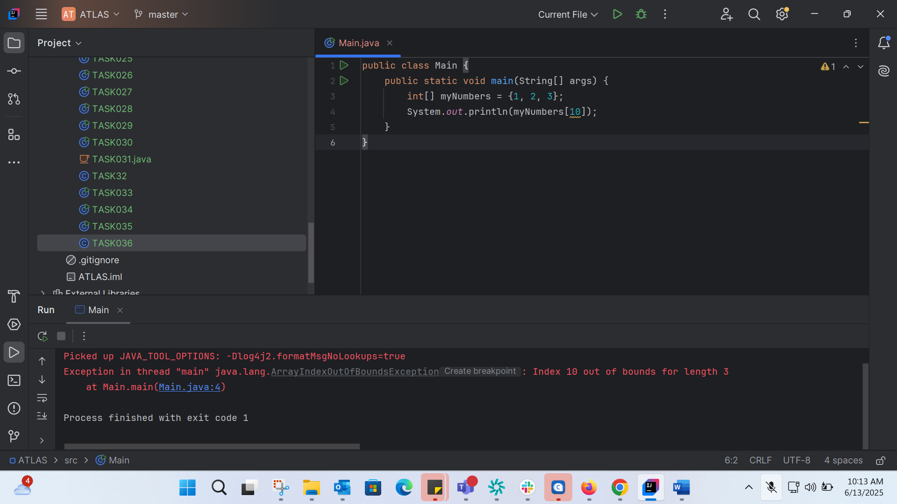
TASK 002: Correct the above code: 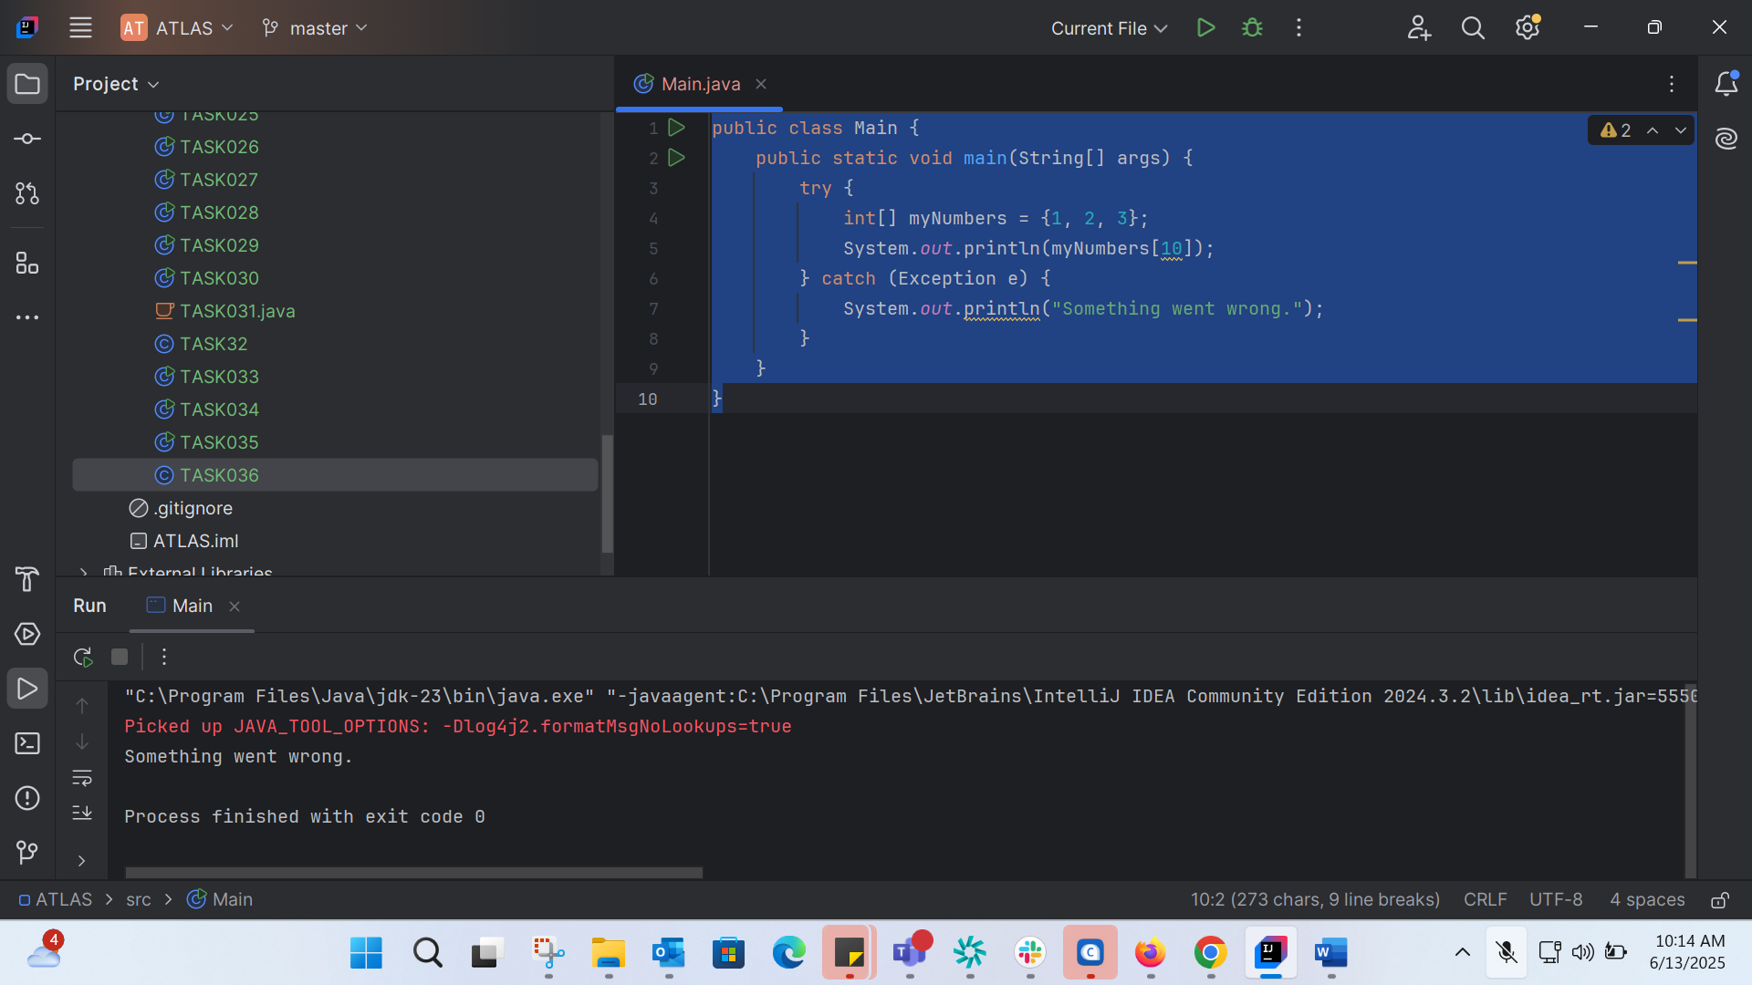
TASK0003: 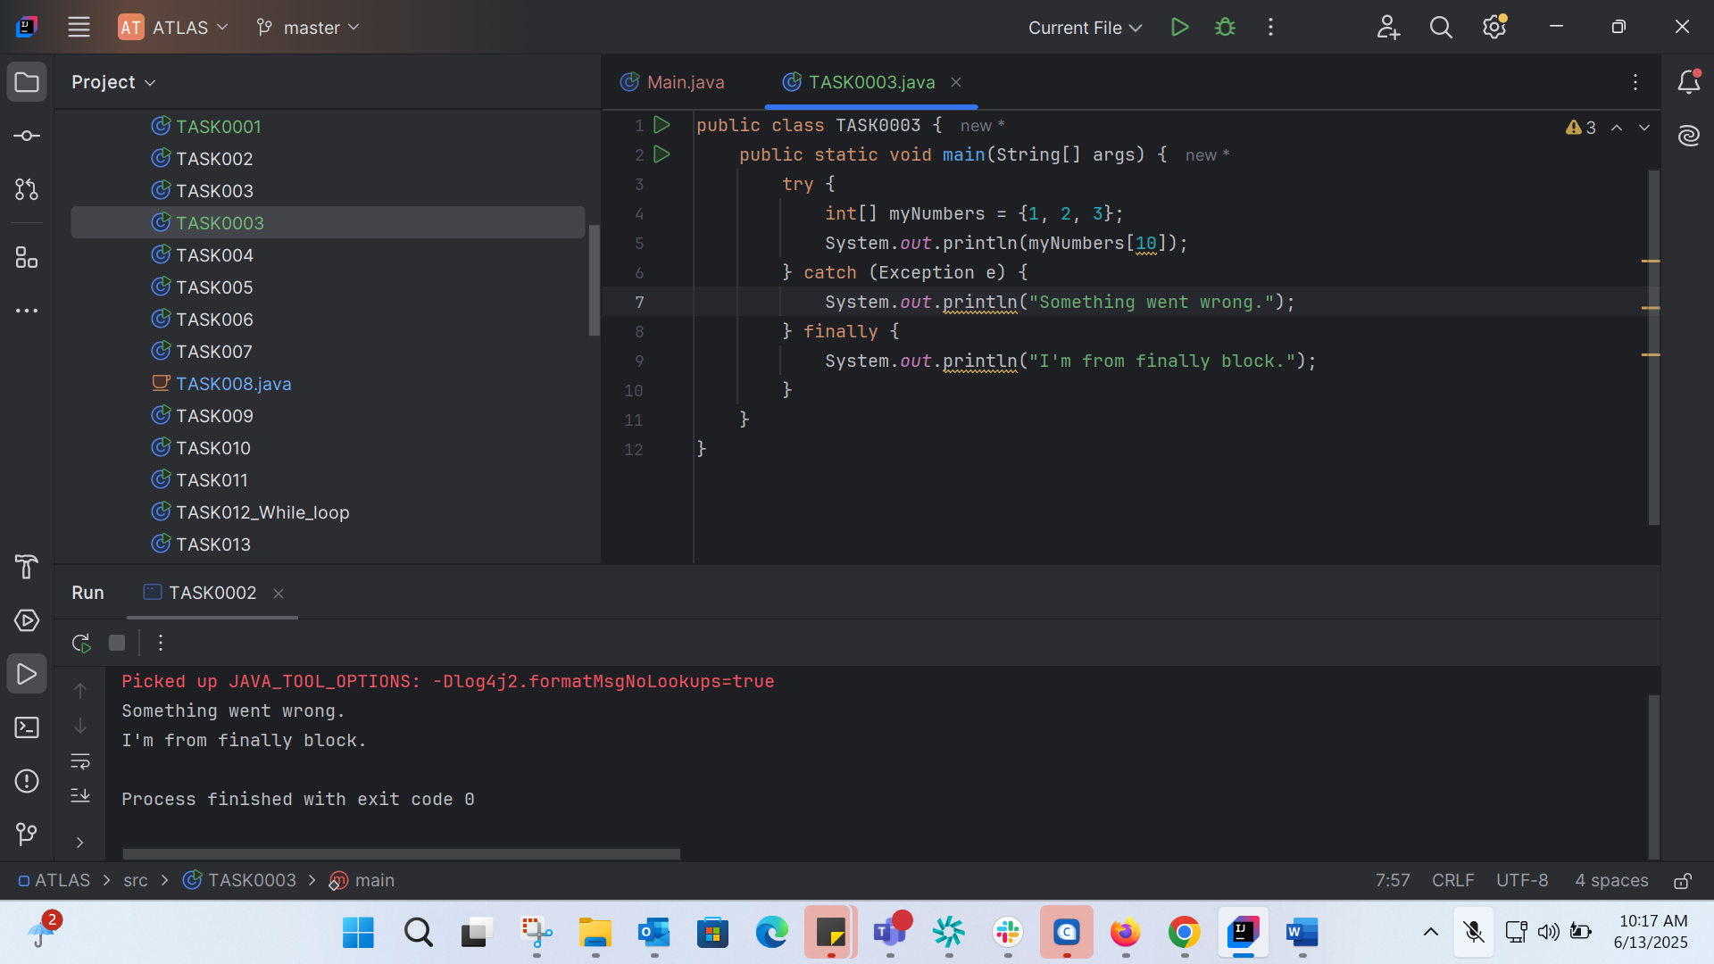
public class TASK0003 {
public static void main(String[] args) {
try {
int[] myNumbers = {1, 2, 3};
System.out.println(myNumbers[10]);
} catch (Exception e) {
System.out.println("Something went wrong.");
} finally {
System.out.println("I'm from finally block.");
}
}
}

TASK0004: 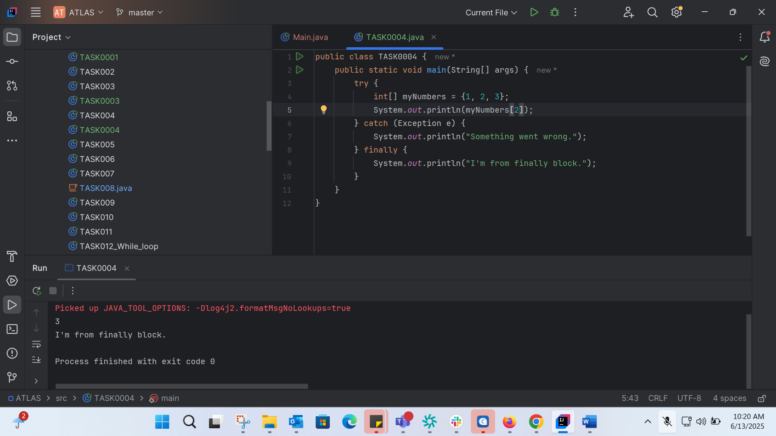
public class TASK0004 {
public static void main(String[] args) {
try {
int[] myNumbers = {1, 2, 3};
System.out.println(myNumbers[2]);
} catch (Exception e) {
System.out.println("Something went wrong.");
} finally {
System.out.println("I'm from finally block.");
}
}
}

Error Handeling:
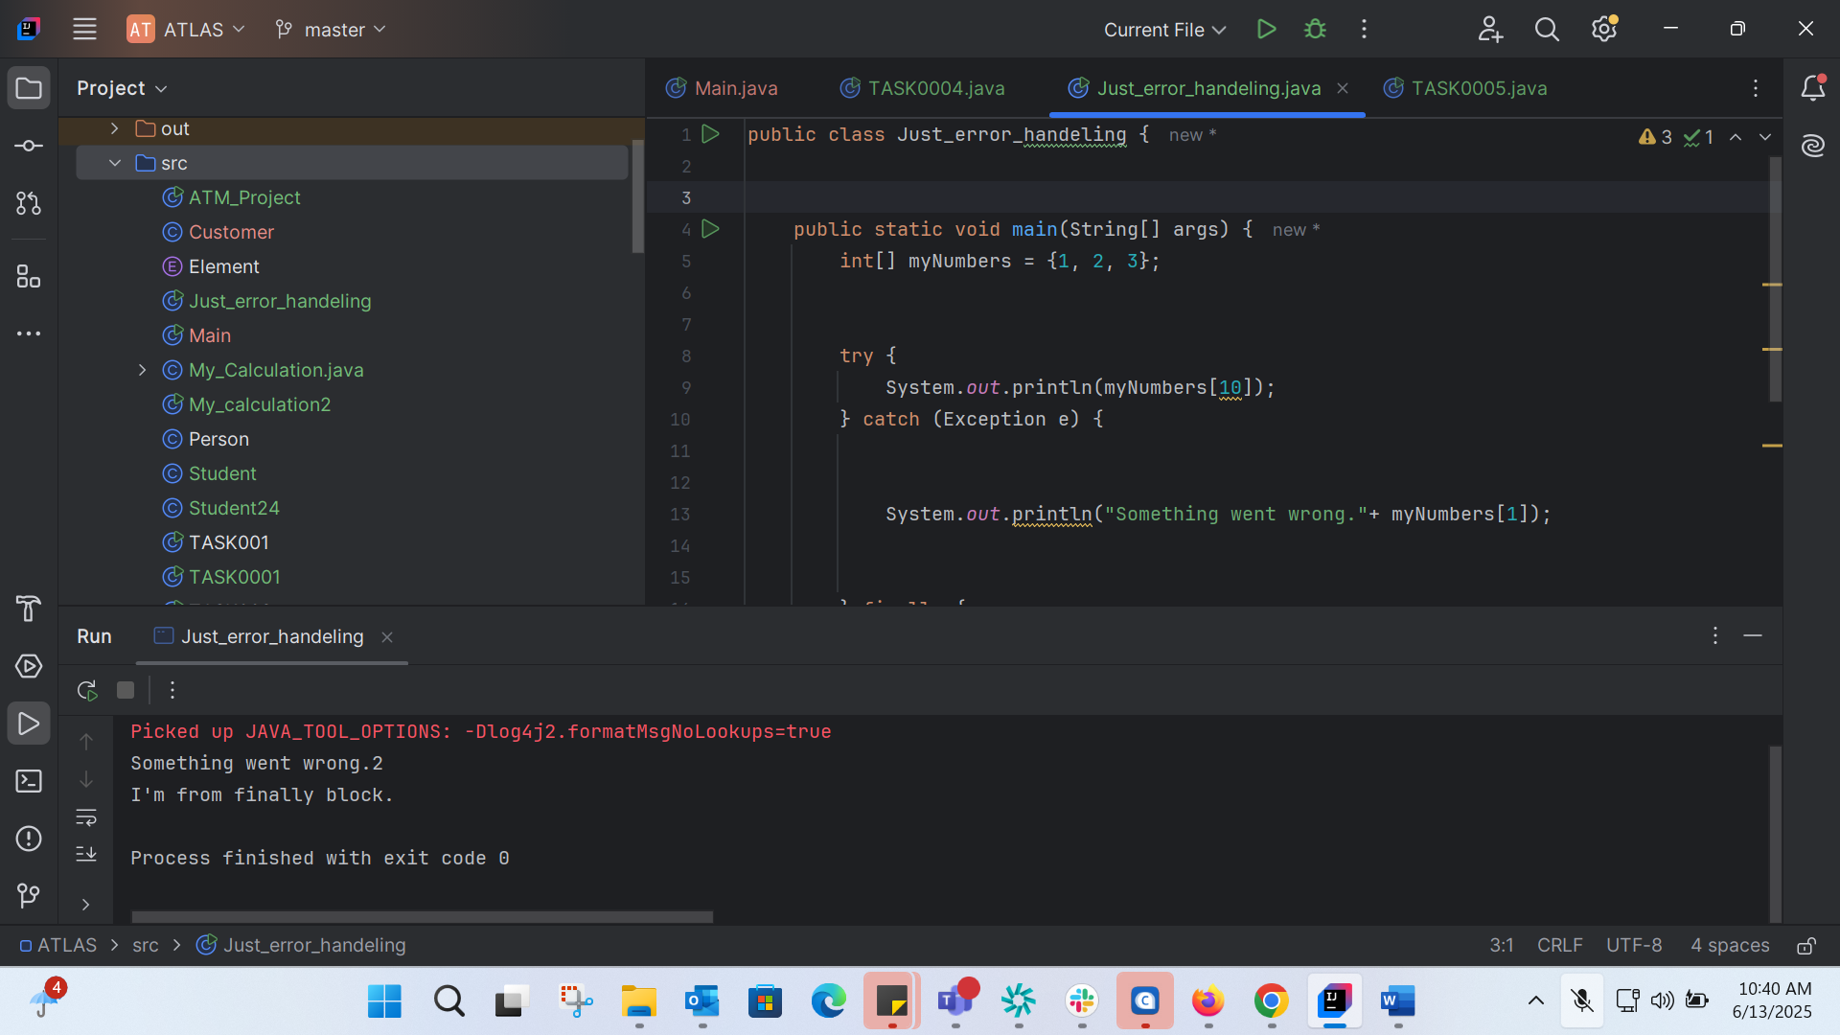
TASK0005: 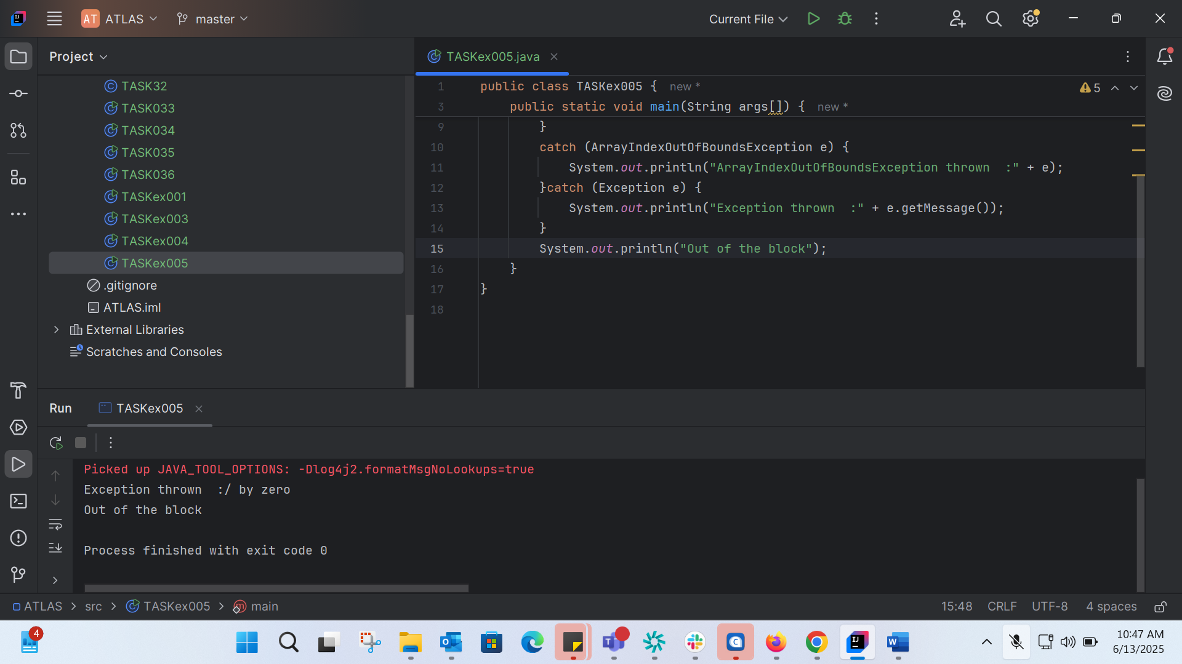
TASK006: 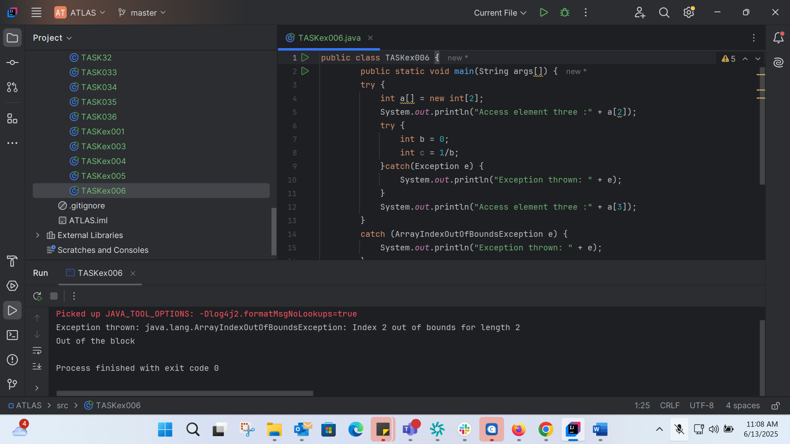
Accessing 0 index: 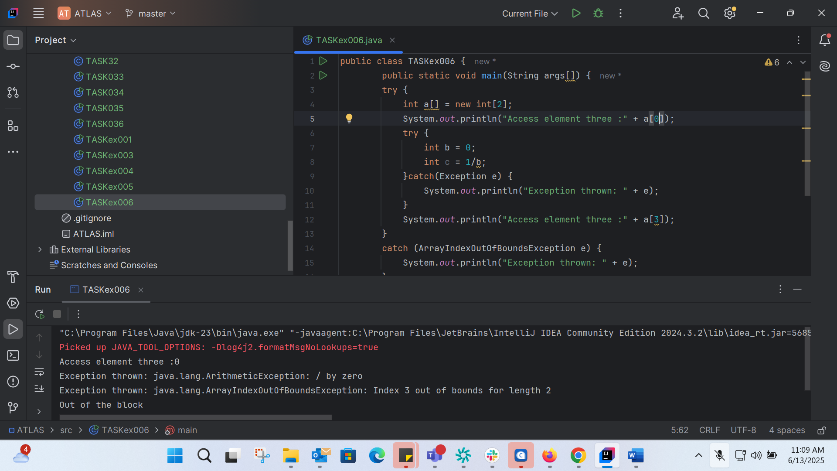
Accessing 1: 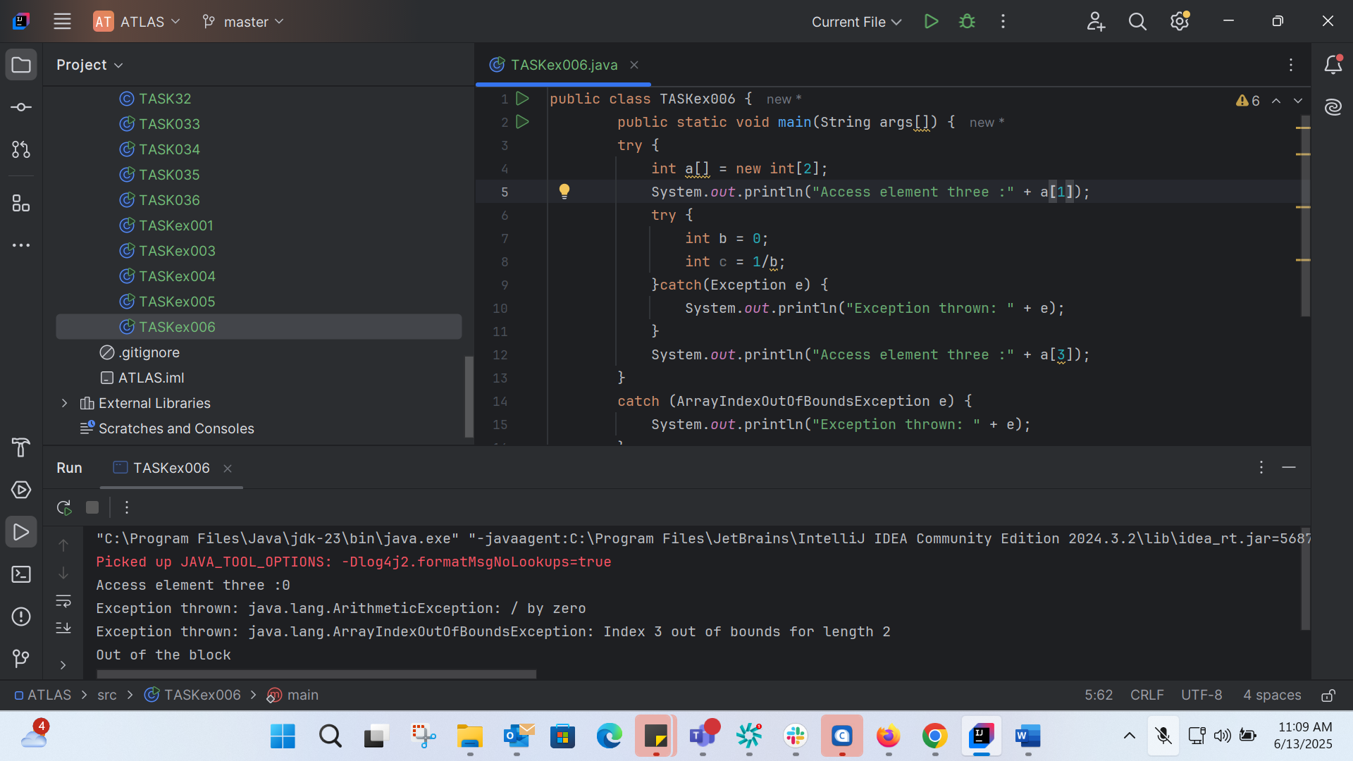
TASK007:
class TASKex007 {
static void fun() throws IllegalAccessException
{
System.out.println("Inside fun(). ");
throw new IllegalAccessException("demo exception by fun method");
}
public static void main(String args[])
{
try {
fun();
//method2(); → arrayindex…
//Method3() —> file not found….
}
catch (IllegalAccessException e) {
System.out.println("Caught in main." + e.getMessage());
}
}
}

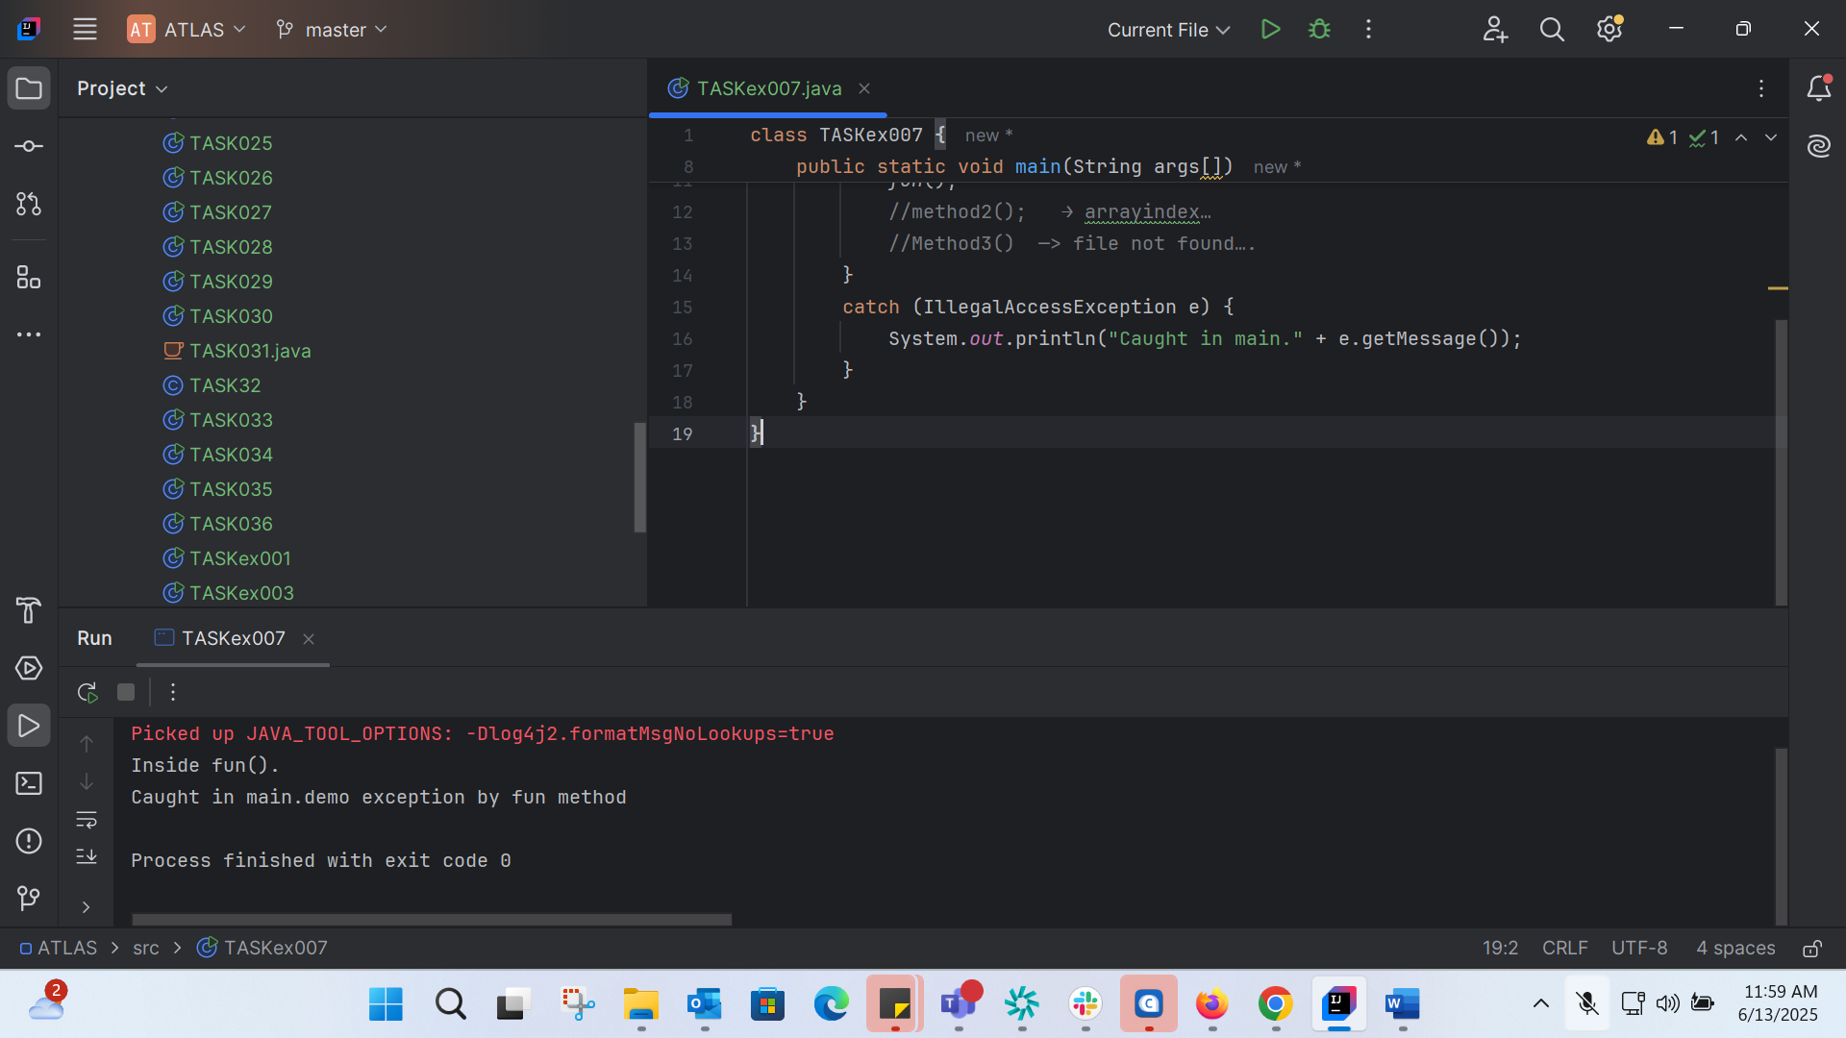
TASK008: 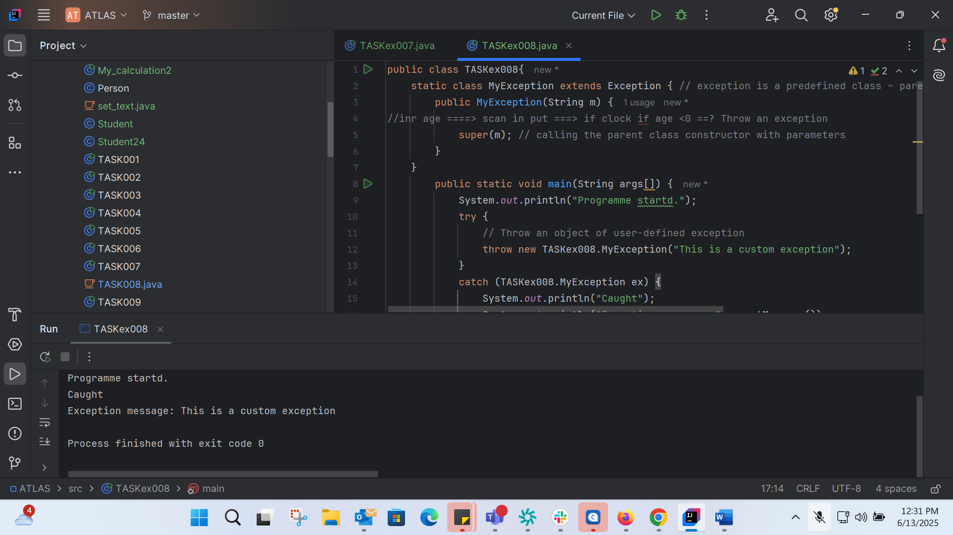
public class TASKex008{
static class MyException extends Exception { // exception is a predefined class – parent class for MyException
public MyException(String m) {
//inr age ====> scan in put ===> if clock if age <0 ==? Throw an exception
super(m); // calling the parent class constructor with parameters
}
}
public static void main(String args[]) {
System.out.println("Programme startd.");
try {
// Throw an object of user-defined exception
throw new TASKex008.MyException("This is a custom exception");
}
catch (TASKex008.MyException ex) {
System.out.println("Caught");
System.out.println("Exception message: "+ex.getMessage());
}
}
}
TASK09: 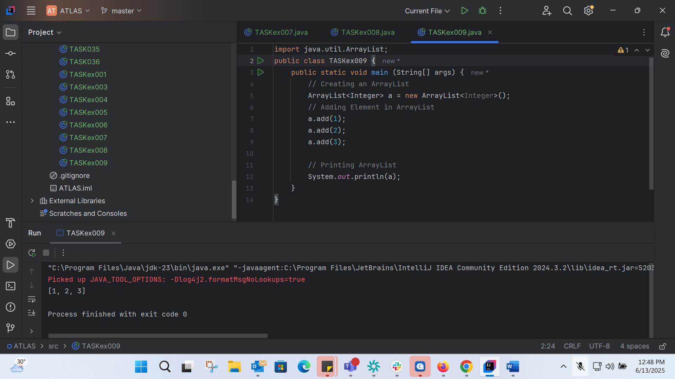
import java.util.ArrayList;
public class TASKex009 {
public static void main (String[] args) {
// Creating an ArrayList
ArrayList<Integer> a = new ArrayList<Integer>();
// Adding Element in ArrayList
a.add(1);
a.add(2);
a.add(3);
// Printing ArrayList
System.out.println(a);
}
}
TASK 10: 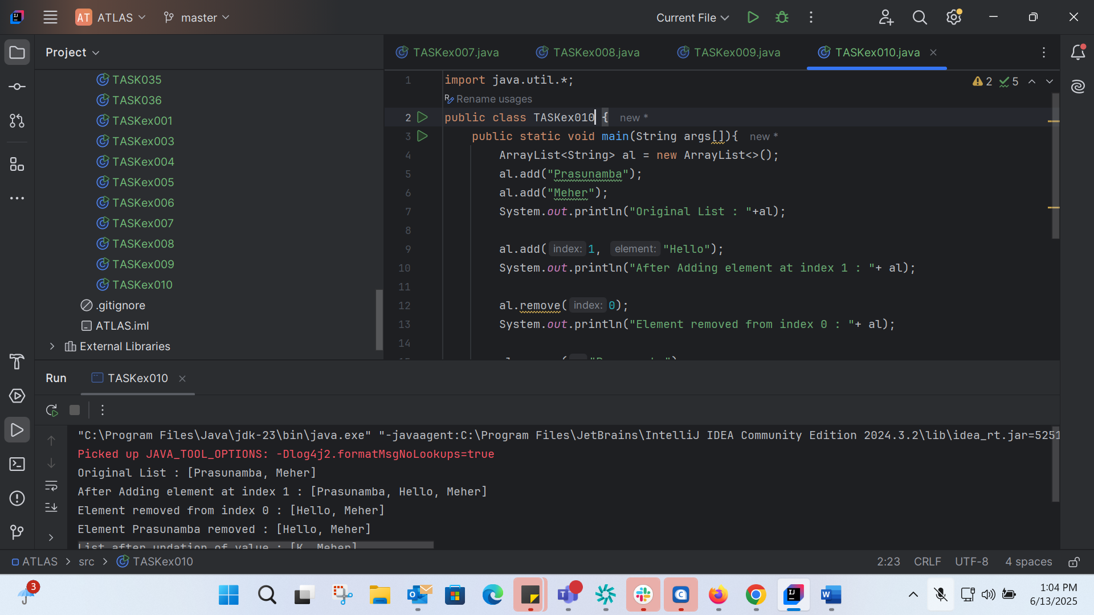
import java.util.*;
public class TASKex010 {
public static void main(String args[]){
ArrayList<String> al = new ArrayList<>();
al.add("Prasunamba");
al.add("Meher");
System.out.println("Original List : "+al);
al.add(1, "Hello");
System.out.println("After Adding element at index 1 : "+ al);
al.remove(0);
System.out.println("Element removed from index 0 : "+ al);
al.remove("Prasunamba");
System.out.println("Element Prasunamba removed : "+ al);
al.set(0, "K");
System.out.println("List after updation of value : "+al);
}
}
TASK 11:
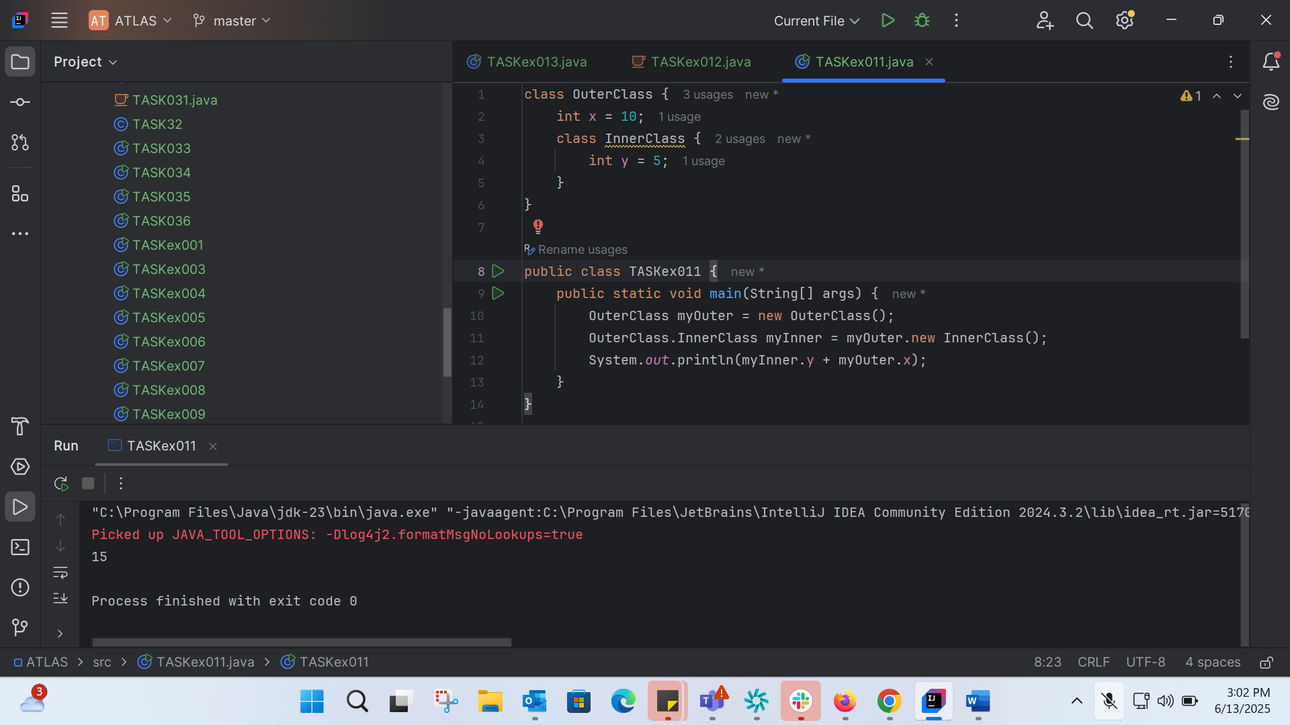
class OuterClass {
int x = 10;
class InnerClass {
int y = 5;
}
}
public class TASKex011 {
public static void main(String[] args) {
OuterClass myOuter = new OuterClass();
OuterClass.InnerClass myInner = myOuter.new InnerClass();
System.out.println(myInner.y + myOuter.x);
}
}

TASK 12:
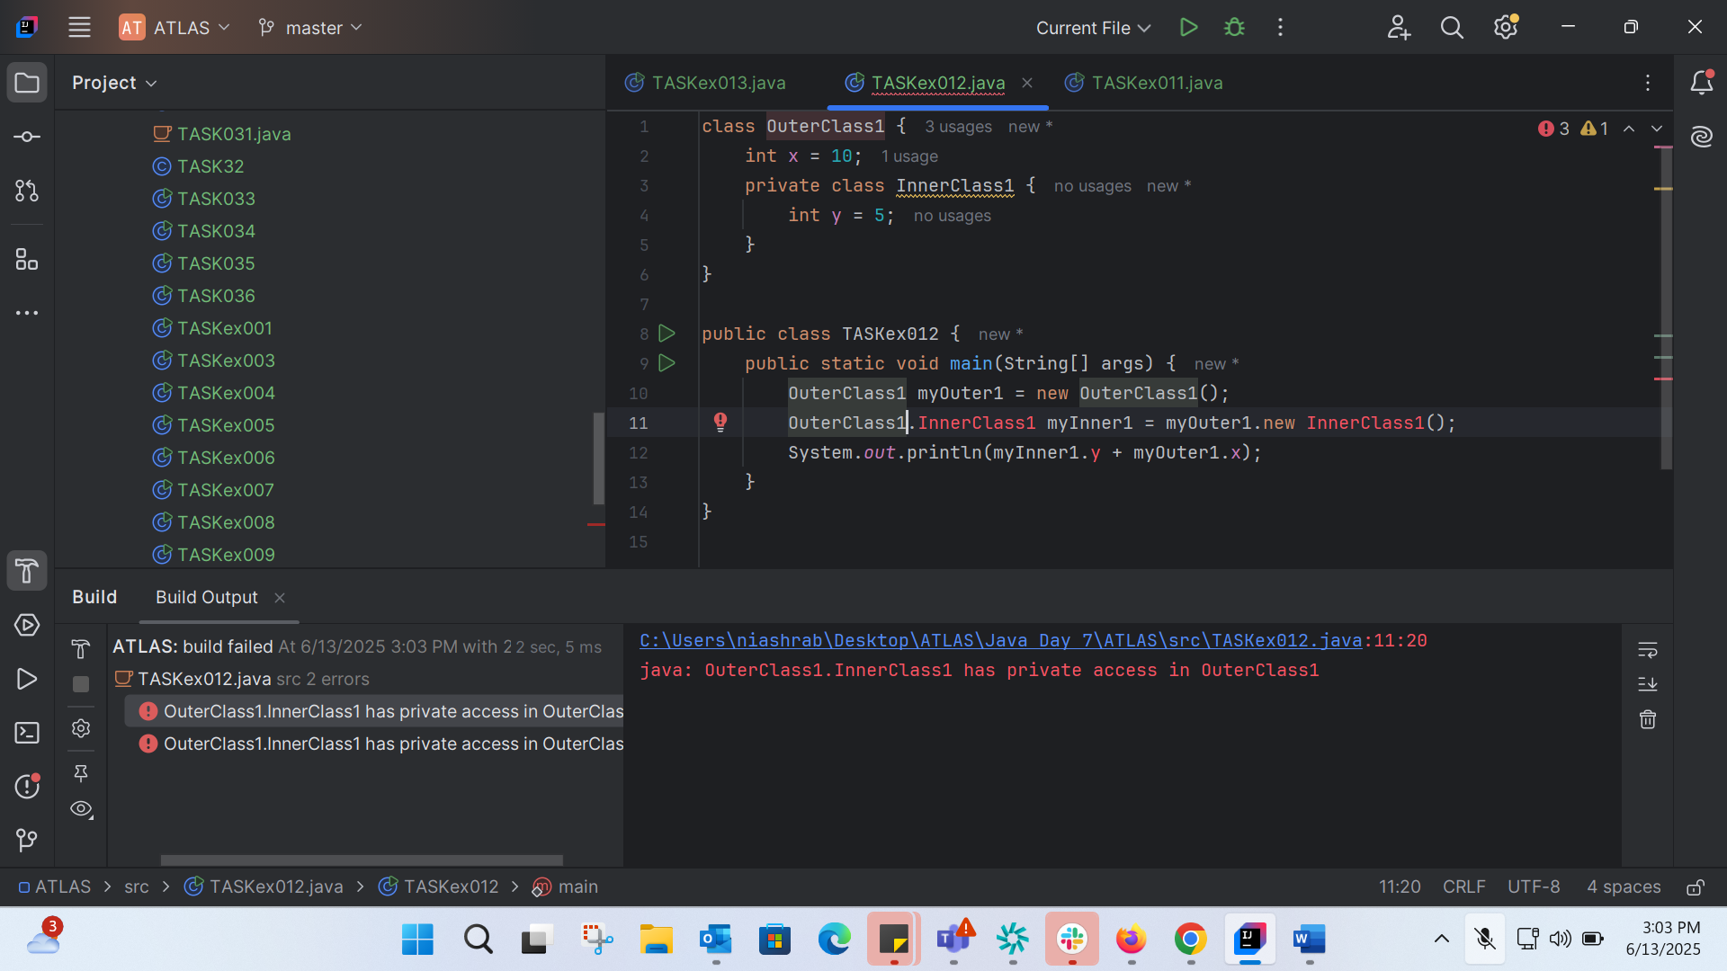
class OuterClass1 {
int x = 10;
private class InnerClass1 {
int y = 5;
}
}
public class TASKex012 {
public static void main(String[] args) {
OuterClass1 myOuter1 = new OuterClass1();
OuterClass1.InnerClass1 myInner1 = myOuter1.new InnerClass1();
System.out.println(myInner1.y + myOuter1.x);
}
}

TASK 13: 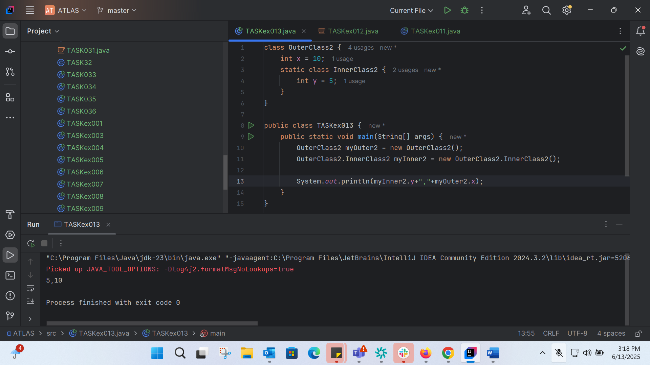

TASK 14: 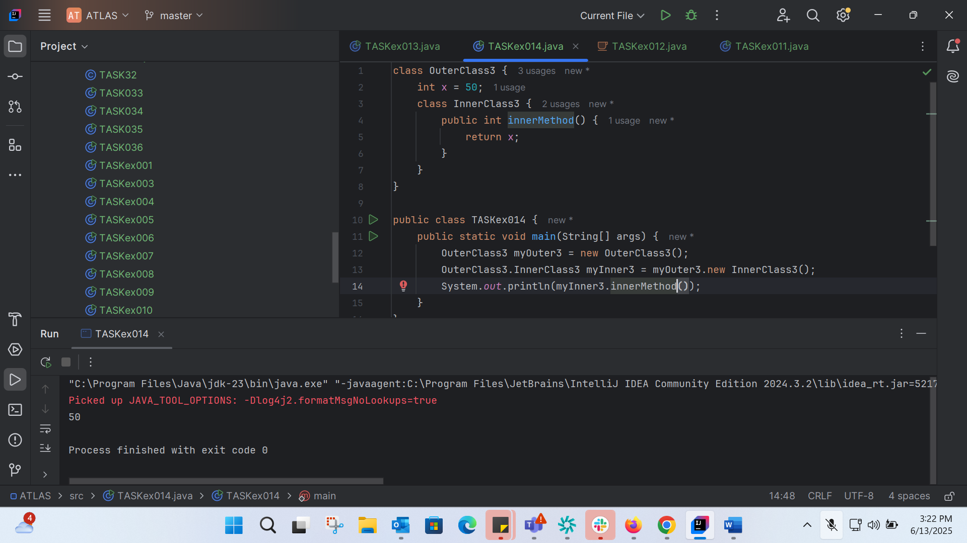
class OuterClass3 {
int x = 50;
class InnerClass3 {
public int innerMethod() {
return x;
}
}
}
public class TASKex014 {
public static void main(String[] args) {
OuterClass3 myOuter3 = new OuterClass3();
OuterClass3.InnerClass3 myInner3 = myOuter3.new InnerClass3();
System.out.println(myInner3.innerMethod());
}
}

TASK015:
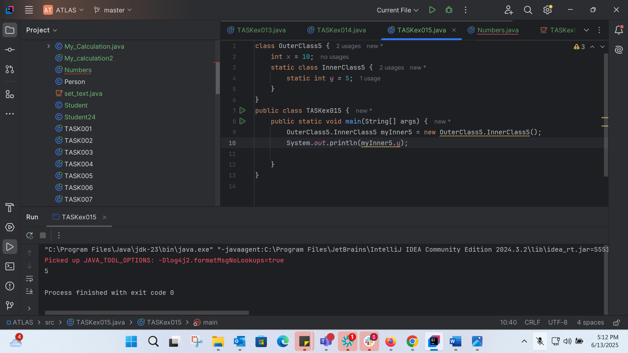
class OuterClass5 {
int x = 10;
static class InnerClass5 {
static int y = 5;
}
}
public class TASKex015 {
public static void main(String[] args) {
OuterClass5.InnerClass5 myInner5 = new OuterClass5.InnerClass5();
System.out.println(myInner5.y);
}
}

TASK 16 :
// Abstract Parent Class
abstract class Personex16 {
private String name;
private int age;
// Constructor
public Personex16(String name, int age) {
this.name = name;
this.age = age;
}
// Getters and Setters
public String getName() { return name; }
public int getAge() { return age; }
public void setName(String name) { this.name = name; }
public void setAge(int age) { this.age = age; }
// Abstract Method
public abstract String toString();
}
// Child class of Person
class Employee extends Personex16 {
private String empId;
private String department;
public Employee(String name, int age, String empId, String department) {
super(name, age);
this.empId = empId;
this.department = department;
}
public String getEmpId() { return empId; }
public String getDepartment() { return department; }
public void setEmpId(String empId) { this.empId = empId; }
public void setDepartment(String department) { this.department = department; }
public String toString() {
return "Name: " + getName() + ", Age: " + getAge() +
", Emp ID: " + empId + ", Department: " + department;
}
}
// Sub-child class of Employee
class Manager extends Employee {
private String team;
private int experience;
public Manager(String name, int age, String empId, String department, String team, int experience) {
super(name, age, empId, department);
this.team = team;
this.experience = experience;
}
public String getTeam() { return team; }
public int getExperience() { return experience; }
public void setTeam(String team) { this.team = team; }
public void setExperience(int experience) { this.experience = experience; }
public String toString() {
return super.toString() +
", Team: " + team + ", Experience: " + experience + " years";
}
}
// Driver class
public class TASKex016 {
public static void main(String[] args) {
Manager manager = new Manager("Ravi", 35, "E123", "IT", "Backend Team", 10);
System.out.println(manager.toString());
}
}

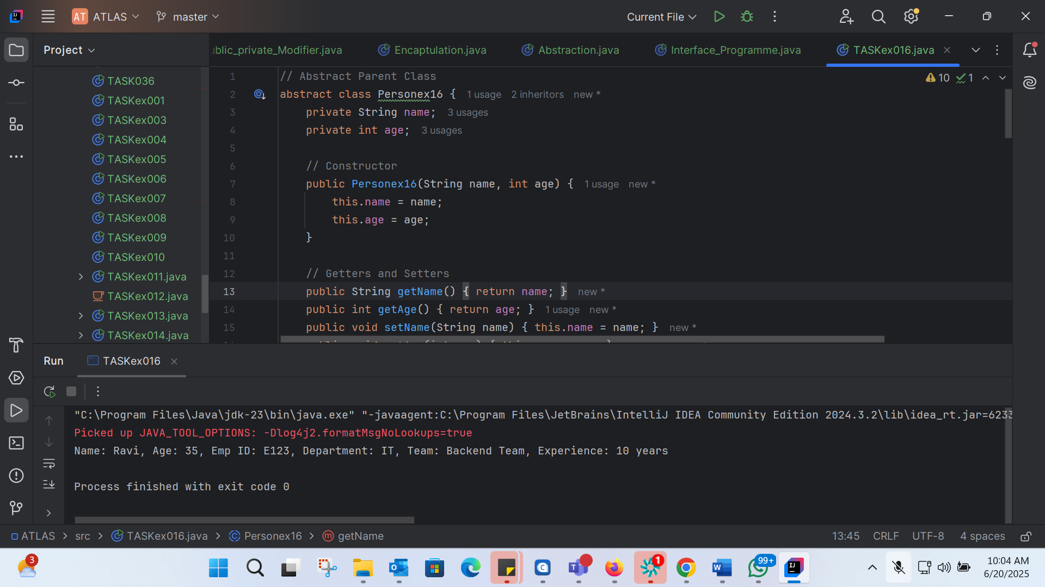

TASK 17 :
Feature of JAVA 8:
- Lambda Expressions
- Functional Interfaces
- Stream API
- New Date and Time API
- Optional Class
- Default Methords in Interfaces
- Method References
- Parallel Streams
- Nashorn JavaScript Engine
TASK 18: 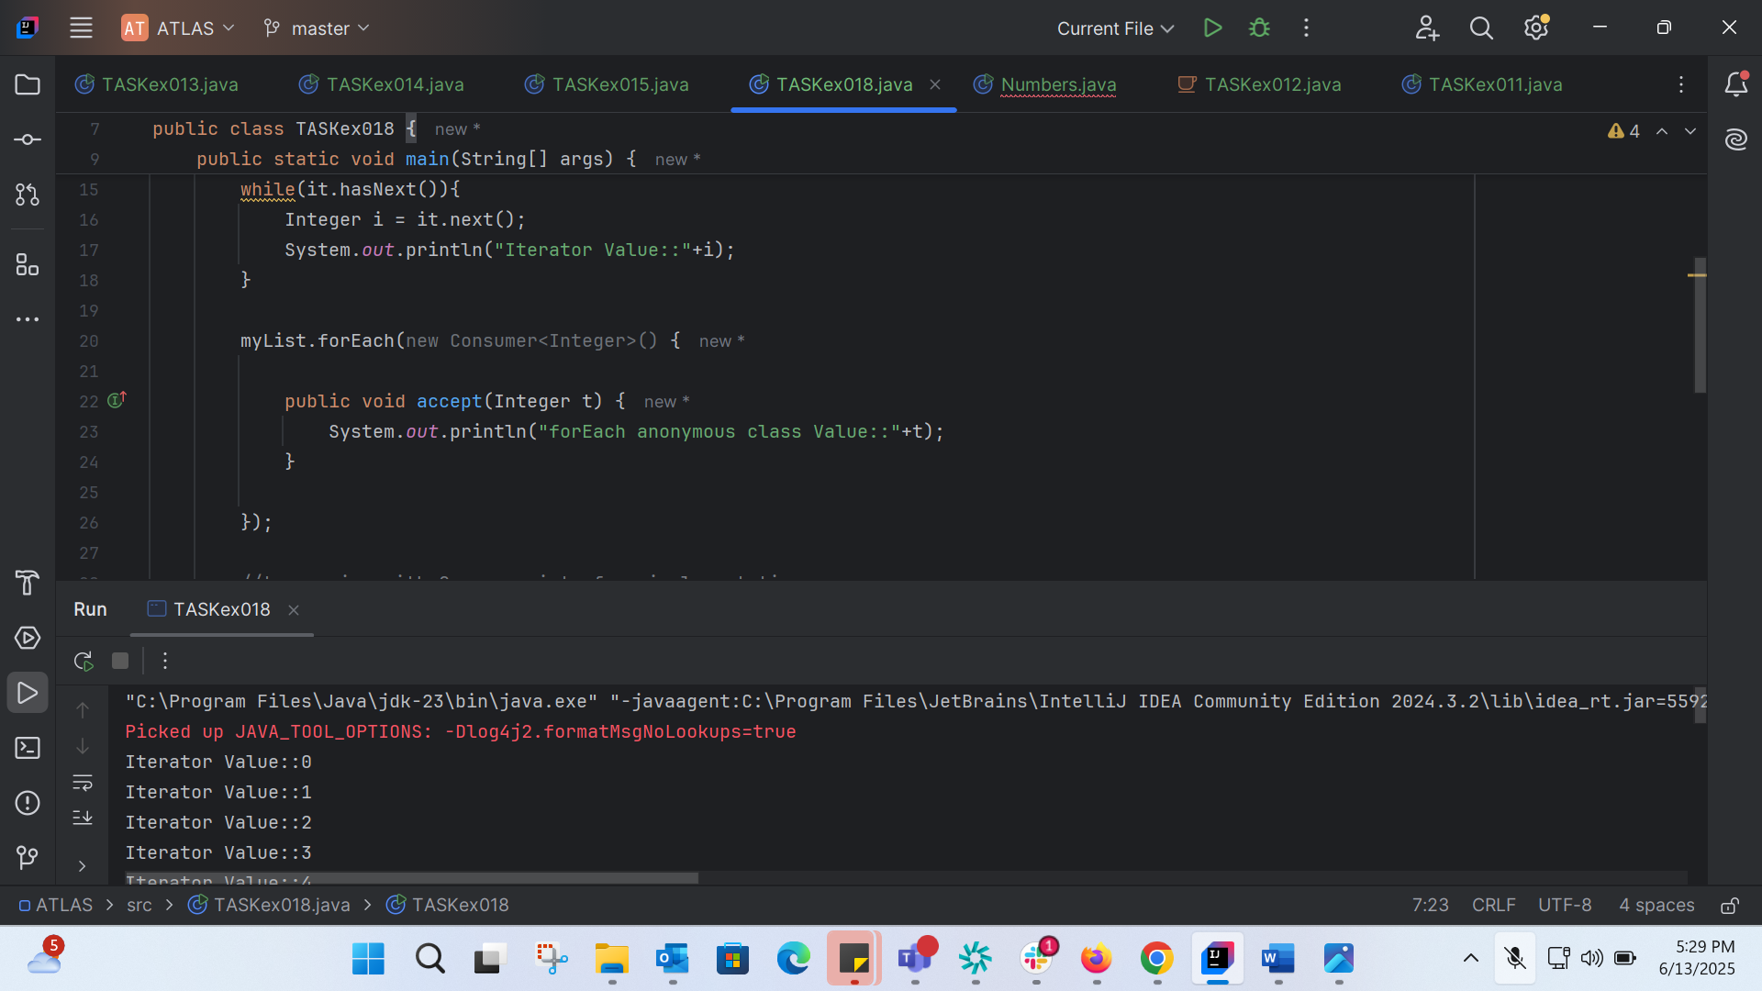
import java.util.ArrayList;
import java.util.Iterator;
import java.util.List;
import java.util.function.Consumer;
import java.lang.Integer;
public class TASKex018 {
public static void main(String[] args) {
List<Integer> myList = new ArrayList<Integer>();
for(int i=0; i<10; i++) myList.add(i);
Iterator<Integer> it = myList.iterator();
while(it.hasNext()){
Integer i = it.next();
System.out.println("Iterator Value::"+i);
}
myList.forEach(new Consumer<Integer>() {
public void accept(Integer t) {
System.out.println("forEach anonymous class Value::"+t);
}
});
//traversing with Consumer interface implementation
MyConsumer action = new MyConsumer();
myList.forEach(action);
}
}
//Consumer implementation that can be reused
class MyConsumer implements Consumer<Integer>{
public void accept(Integer t) {
System.out.println("Consumer impl Value::"+t);
}
}

Iterator Value::0
Iterator Value::1
Iterator Value::2
Iterator Value::3
Iterator Value::4
Iterator Value::5
Iterator Value::6
Iterator Value::7
Iterator Value::8
Iterator Value::9
forEach anonymous class Value::0
forEach anonymous class Value::1
forEach anonymous class Value::2
forEach anonymous class Value::3
forEach anonymous class Value::4
forEach anonymous class Value::5
forEach anonymous class Value::6
forEach anonymous class Value::7
forEach anonymous class Value::8
forEach anonymous class Value::9
Consumer impl Value::0
Consumer impl Value::1
Consumer impl Value::2
Consumer impl Value::3
Consumer impl Value::4
Consumer impl Value::5
Consumer impl Value::6
Consumer impl Value::7
Consumer impl Value::8
Consumer impl Value::9

TASK 19:

TASK 20: 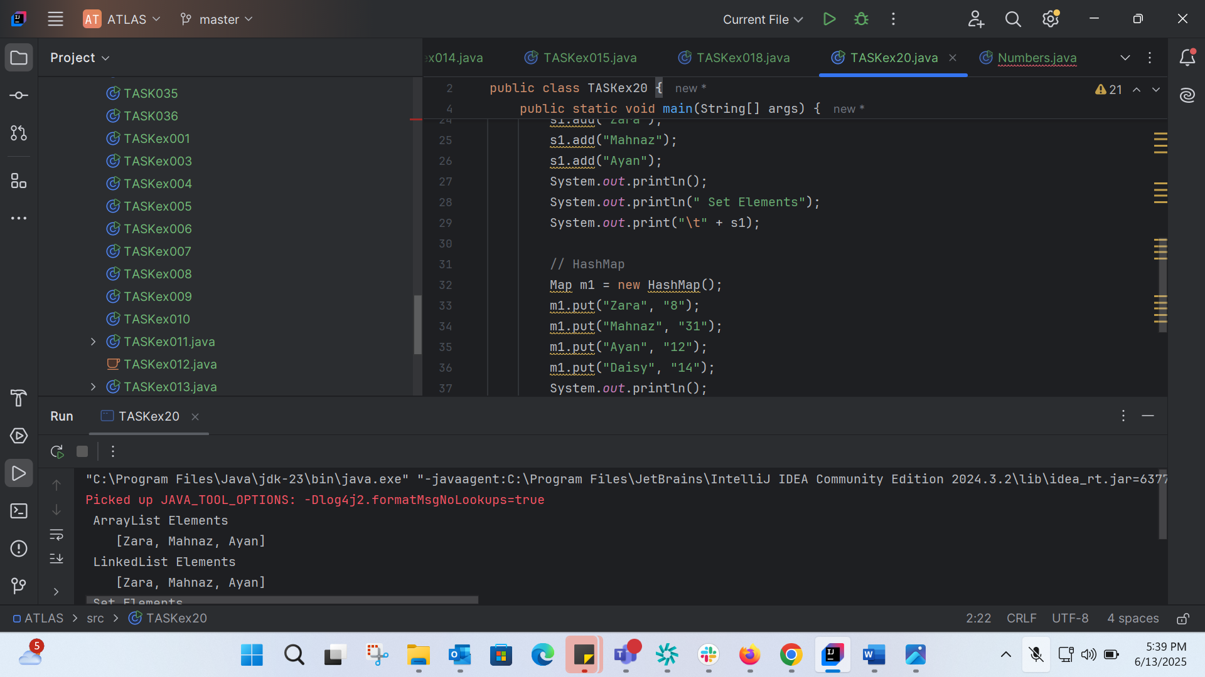
import java.util.*;
public class TASKex20 {
public static void main(String[] args) {
// ArrayList
List a1 = new ArrayList();
a1.add("Zara");
a1.add("Mahnaz");
a1.add("Ayan");
System.out.println(" ArrayList Elements");
System.out.print("\t" + a1);
// LinkedList
List l1 = new LinkedList();
l1.add("Zara");
l1.add("Mahnaz");
l1.add("Ayan");
System.out.println();
System.out.println(" LinkedList Elements");
System.out.print("\t" + l1);
// HashSet
Set s1 = new HashSet();
s1.add("Zara");
s1.add("Mahnaz");
s1.add("Ayan");
System.out.println();
System.out.println(" Set Elements");
System.out.print("\t" + s1);
// HashMap
Map m1 = new HashMap();
m1.put("Zara", "8");
m1.put("Mahnaz", "31");
m1.put("Ayan", "12");
m1.put("Daisy", "14");
System.out.println();
System.out.println(" Map Elements");
System.out.print("\t" + m1);
}
}
ArrayList Elements
[Zara, Mahnaz, Ayan]
LinkedList Elements
[Zara, Mahnaz, Ayan]
Set Elements
[Ayan, Zara, Mahnaz]
Map Elements
{Daisy=14, Ayan=12, Zara=8, Mahnaz=31}

